Dashboards:

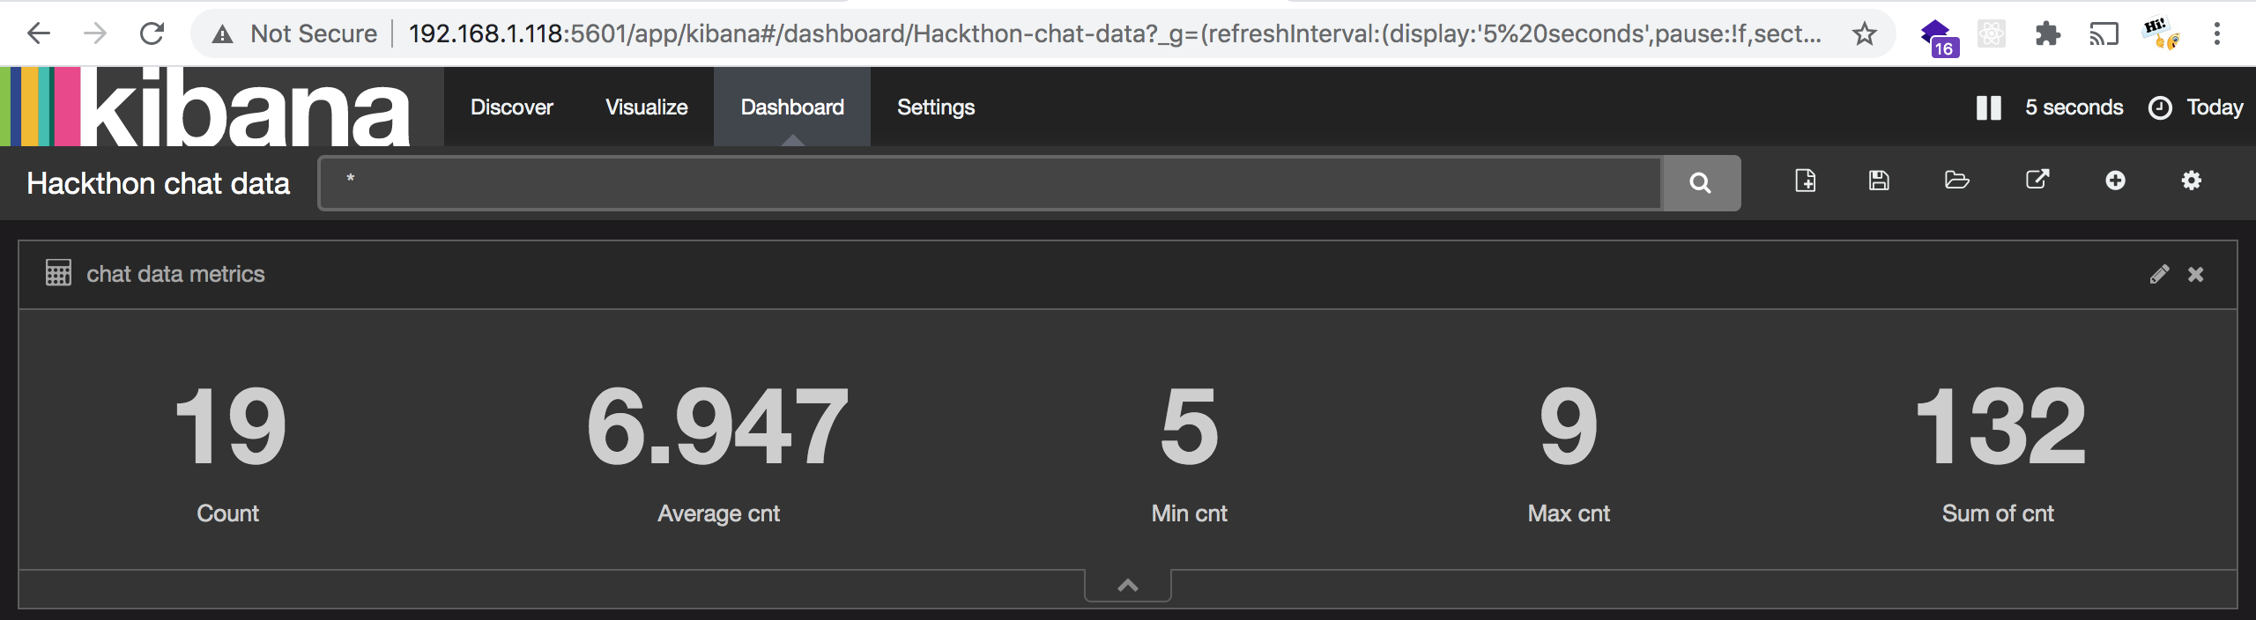

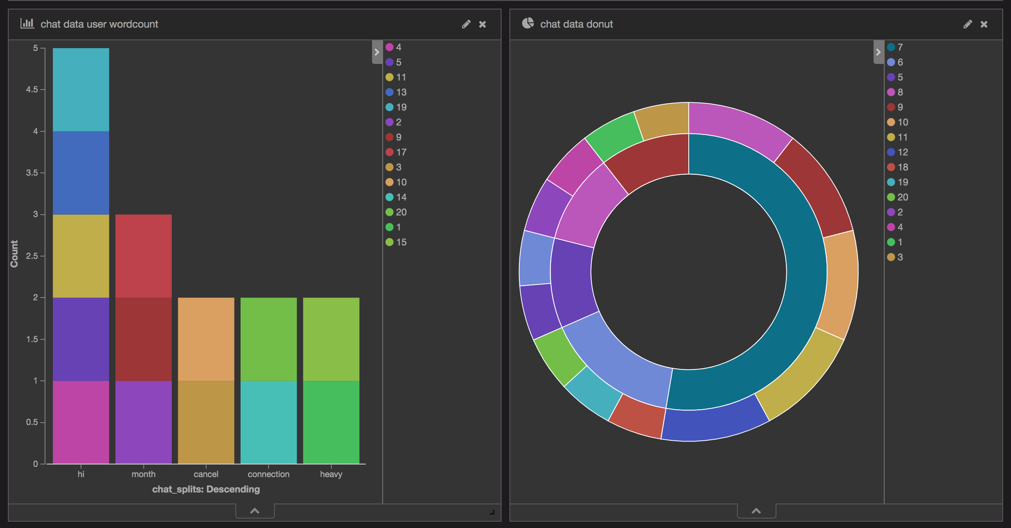

Metrics

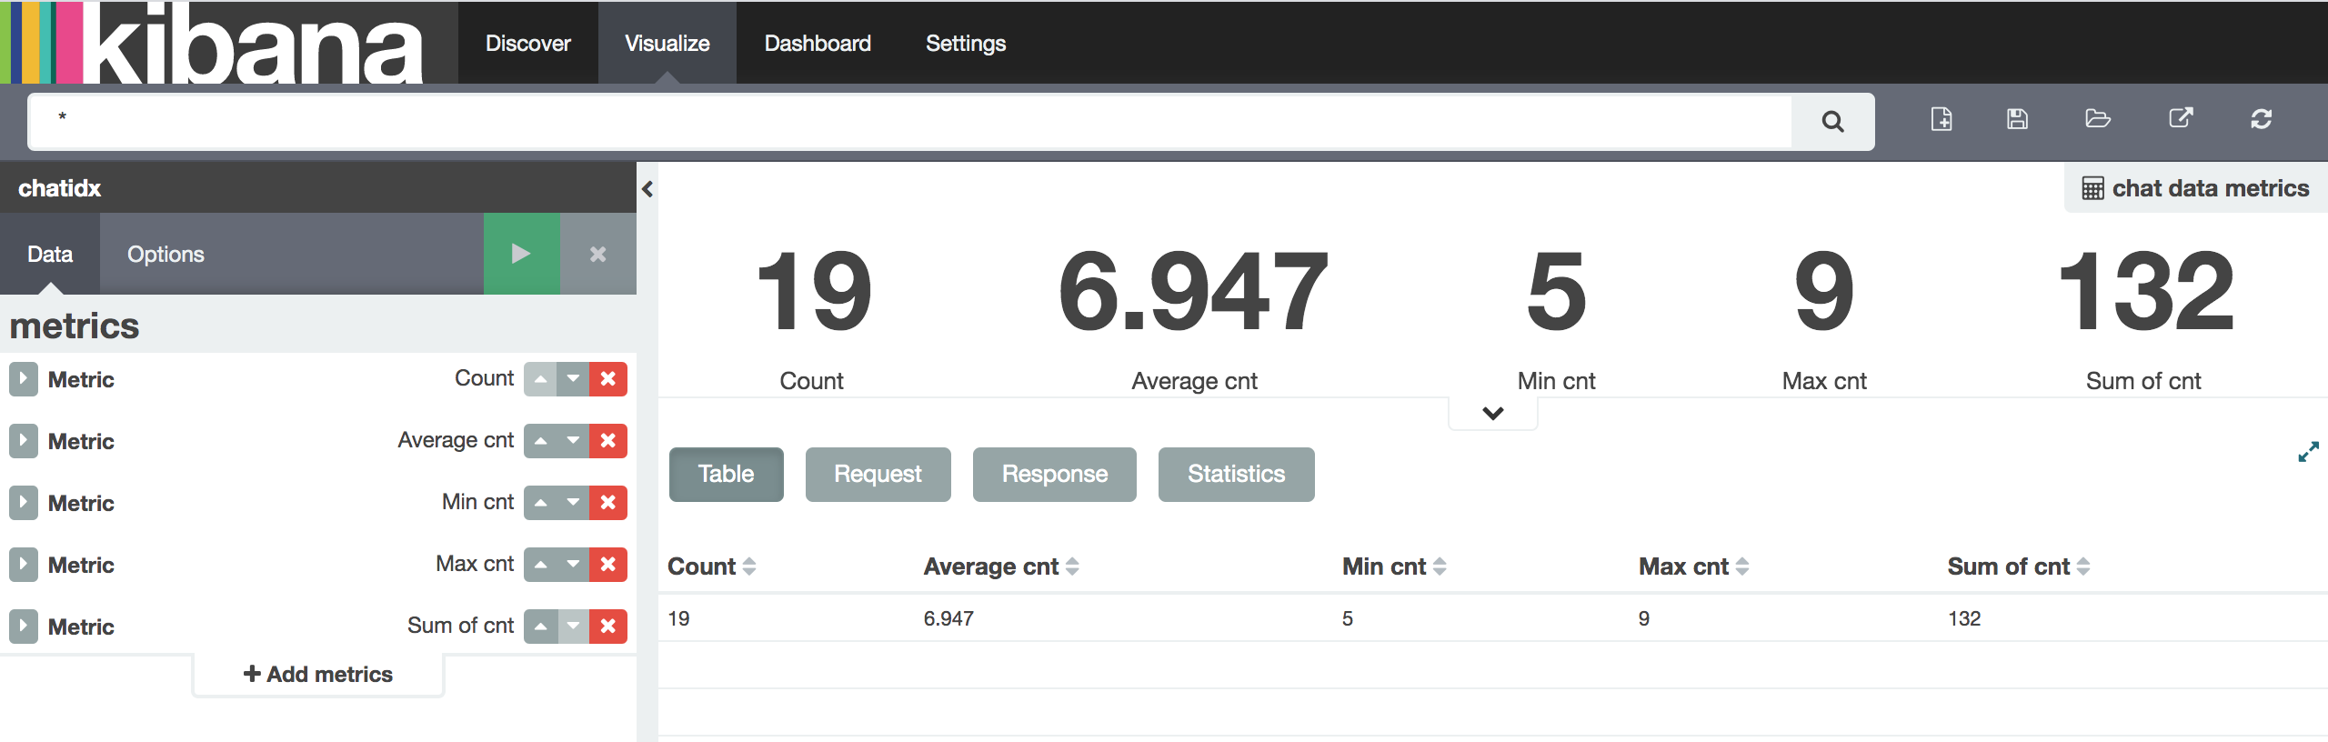

Bar chat

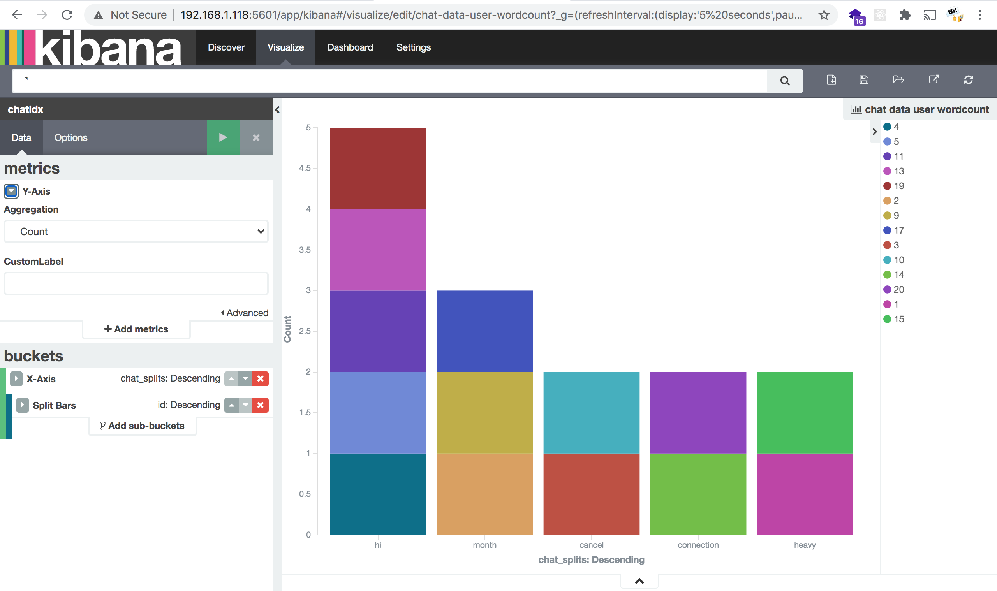

Donut chat

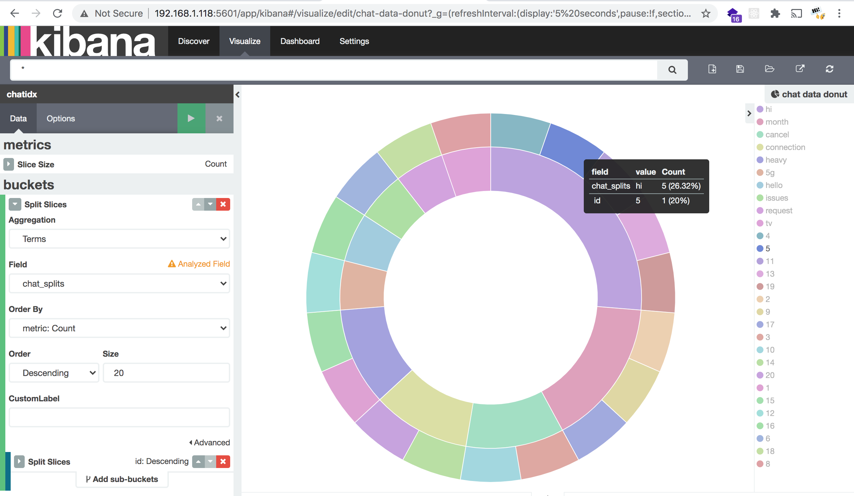

[http://192.168.1.118:5601/app/kibana#/dashboard/Hackthon-chat-data?_g=(refreshInterval:(display:'5%20seconds',pause:!f,section:1,value:5000),time:(from:now%2Fd,mode:quick,to:now%2Fd))&_a=(filters:!(),options:(darkTheme:!t),panels:!((col:1,id:chat-data-metrics,panelIndex:2,row:1,size_x:12,size_y:2,type:visualization),(col:7,id:chat-data-donut,panelIndex:3,row:3,size_x:6,size_y:6,type:visualization),(col:1,id:chat-data-user-wordcount,panelIndex:4,row:3,size_x:6,size_y:6,type:visualization)),query:(query_string:(analyze_wildcard:!t,query:'*')),title:'Hackthon%20chat%20data',uiState:())](http://192.168.1.118:5601/app/kibana#/dashboard/Hackthon-chat-data?_g=(refreshInterval:(display:'5%20seconds',pause:!f,section:1,value:5000),time:(from:now%2Fd,mode:quick,to:now%2Fd))&_a=(filters:!(),options:(darkTheme:!t),panels:!((col:1,id:chat-data-metrics,panelIndex:2,row:1,size_x:12,size_y:2,type:visualization),(col:7,id:chat-data-donut,panelIndex:3,row:3,size_x:6,size_y:6,type:visualization),(col:1,id:chat-data-user-wordcount,panelIndex:4,row:3,size_x:6,size_y:6,type:visualization)),query:(query_string:(analyze_wildcard:!t,query:'*')),title:'Hackthon%20chat%20data',uiState:()))